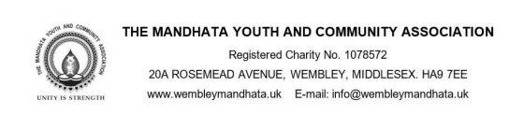
MYCA WEMBLEY MEMBERSHIP FORM
The Mandhata Youth & Community Association is a registered charitable organisation, established to promote social welfare of the Community. Individuals over the age of 18 years are entitled to become either an Annual member, Life member, Patron or Donor by paying the current membership fee. Members are entitled to participate in all open meetings, having voting rights and to seek any electable position in the Association. Members will be provided with notice of such meetings and receive information about the activities that are organised during the year via e-mail. According to the constitution of the Association, any person wishing to become a member must fill in the application form and submit the same along with the required fee to the Secretary at the postal address or e-mail above. We will only use your details to keep you informed of relevant news. We will not pass on your information to third parties. Membership will be at the discretion of the management.
Full name
Address & Postcode
E-mail Address
Contact Number (landline/mobile)
Village in India (optional)
Membership – Please tick as appropriate
Annual Member (valid from 1st April – 31st March) : £10.00 ☐
Life Member (a passport size photograph is required with the application) : £151.00 ☐
Donor : £251.00 ☐ Patron : £351.00 ☐
Method of Payment: Cash ☐ Cheque - made payable to MYCA ☐ Bank Transfer ☐
Bank Transfer Details: Account Name: Mandhata Youth And Community Association Account
Number: 00603570 Sort Code: 20-01-89 (Please enter your full name as reference)
I wish to become a member of the Mandhata Youth and Community Association. My acceptance as a member requires me to abide by the constitution and the Association’s objectives.

Signature: …………………………………………. Date: ……………………

For office use only
Form Number: | Issued by: | Date of issue:
Payment received by: |  | Receipt Number:
Membership Number: | Card issued by: | Date:

President: Kusumben P Soma Treasurer: Saajan Soma Secretary: Heena A Patel
Updated July 2022

